Carbonization Wind Transmitter
(485Type)


Catalogue
Chapter 1 Product Introduction 3
1.1 Product Overview 3
1.2 Functional characteristics 3
1.3 Main parameters 3
1.4 System framework diagram 4
1.5 Product selection 5
Chapter 2 Hardware Connection 6
2.1Pre-installation inspection of equipment 6
2.2Interface description 6
2.2.1 Sensor wiring 6
2.3 Installation method 6
2.4 Notes 7
Chapter 4 Communication protocol 8
4.1 Basic parameters of communication 8
4.2 Definition of data frame format 8
4.3 Register address 9
4.4 Numerical correspondence conversion relationship 9
4.5 Examples and explanations of communication protocols 10
Chapter 5 Frequently Asked Questions and Solutions 10

Chapter 1 Product Introduction

1.1 Product Overview
The wind direction sensor is small and light in appearance, which is easy to carry and assemble. The three-cup design concept can effectively obtain external environmental information. The shell is made of polycarbonate composite material, and the exterior is electroplated and sprayed, which has good anti-corrosion, anti-erosion and other characteristics, which can ensure the long-term use of the instrument without rust, and at the same time cooperate with The internal smooth bearing system ensures the accuracy of information collection. It is widely used in wind direction measurement in greenhouses, environmental protection, weather stations, ships, docks, breeding and other environments.

1.2 Functional characteristics
- The range of measurement:0~360° Or 8 directions
- Anti-electromagnetic interference treatment
- Adopt high-performance imported bearings, small rotation resistance, accurate measurement
- Polycarbonate shell, high mechanical strength, high hardness, corrosion resistance, rust-proof, can be used outdoors for a long time
- The structure and weight of the equipment are carefully designed and distributed, with small rotational inertia and sensitive response.
- Standard ModBus-RTU communication protocol, convenient access

1.3 Main parameters
DC power supply(default) | - RS485: DC5~24V
Power consumption | ≤0.15W
Operating temperature of transmitter circuit | -40℃~+60℃, 0%RH~80%RH
Communication interface | 485 Communication (ModBus) Protocol  Baud rate: 2400, 4800, 9600 (default), 19200, 38400, 57600, 115200  Default ModBus communication address:4  Support function code: 03/06
Parameter setting | Use the provisioned configuration software to configure through the 485 interface
Measuring range | 0~360°, support 8 Or 16 Indicate the direction Output of conversion
Dynamic response time | ≤0.5s
Shell Size:
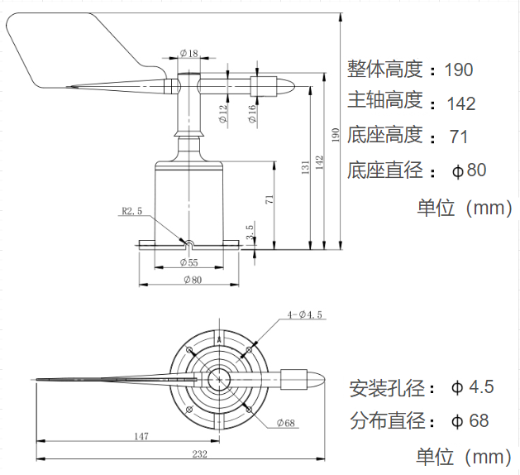

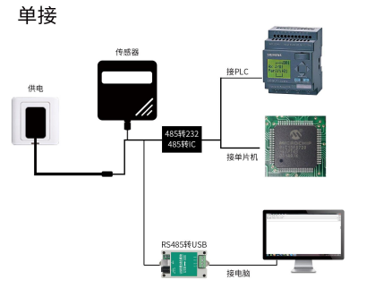
1.4 System framework diagram

This product can also combine multiple sensors in one 485 The bus is used. Theoretically, a bus can Come into contact with 254 Self 485 Sensor, the other end is connected with 485 Interface's PLC. , pass 485 Connect the interface chip to the single-chip computer, or use Universal serial bus Embellish one's speech with literary quotations 485 It can be connected to the computer and used the sensor configuration tool provided by our company for configuration and testing (only one device can be connected when using this configuration software).
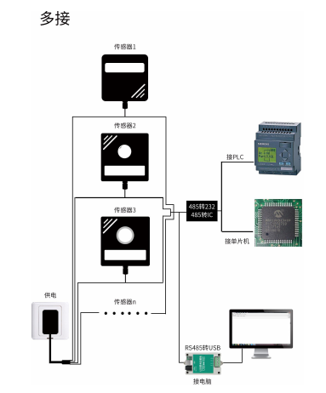

Chapter 2 Hardware Connection

2.1Pre-installation inspection of equipment
Equipment list:
■ 1 transmitter equipment
■ 4 mounting screws
■ Qualification certificate, warranty card

2.2 Interface description
Wide voltage power input 5~12V. When wiring the 485 signal line, pay attention to the two lines A\B should not be reversed, and the addresses between multiple devices on the bus should not conflict.

2.2.1 Sensor wiring
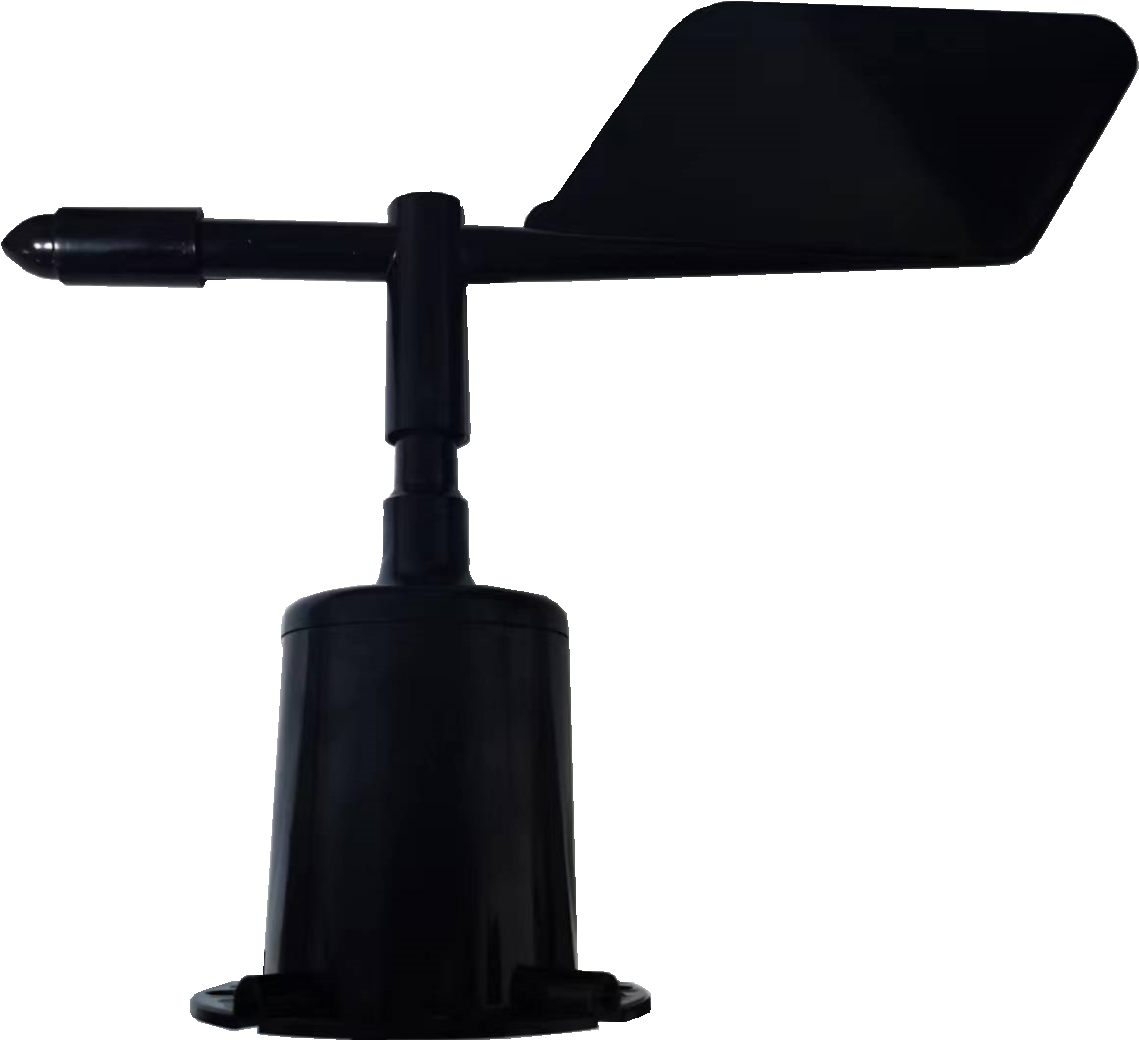

2.3 Installation method
 | Line color | Explain
Power supply | Red | The power supply is positive
Power supply | Black | The power supply is negative
Send out | Yellow | 485-A
Send out | Green | 485-B
With flange installation, the threaded flange connection makes the lower pipe of the wind sensor firmly fixed on the flange, and the chassisØ80mm, in Ø Open four equals on the circumference of 68mmØ The 4.5mm mounting hole is tightly fixed on the bracket with bolts to keep the whole instrument at the best level and ensure the accuracy of wind direction data. The flange connection is convenient to use and can withstand greater pressure.
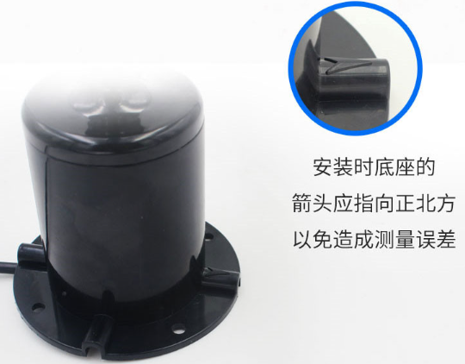
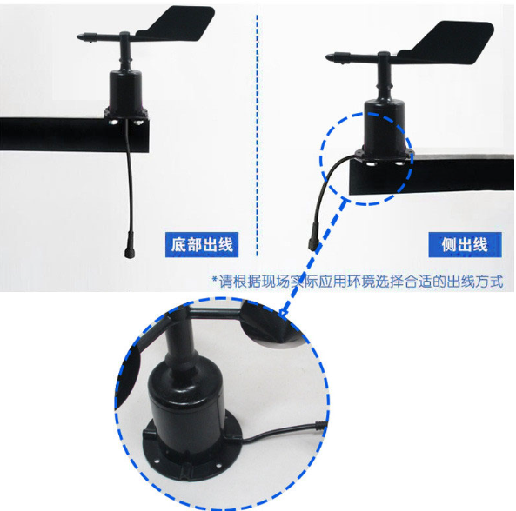

2.4 Notes
1. Users are not allowed to disassemble it by themselves, let alone touch the sensor core, so as not to damage the product.
2. Try to stay away from high-power interference equipment to avoid inaccurate measurement, such as frequency converters, motors, etc. When installing and disassembling the transmitter, the power supply must be disconnected first. Water entering the transmitter can lead to irreversible changes.
3. Prevent chemical reagents, oil, dust, etc. from directly infringing the sensor, do not in the condensation and extreme temperature ring.Long-term use under the situation, strictly prevent cold and heat shocks.

Chapter 4 Communication protocol

4.1 Basic parameters of communication
Code | 8-bit binary
Data bit | 8 bit
Odd and even check bit | Not have
Stop position | 1 bit
Error check | CRC (Redundant Loop Code)
Baud rate | Factory default 9600bit/s

4.2 Definition of data frame format
The ModBus-RTU communication protocol is adopted, and the format is as follows:
Time of initial structure ≥4 bytes
Address code = 1 byte
Function code = 1 byte
Data area = N byte
Error check = 16-bit CRC code
End structure ≥4 bytes of time
Address code: The address of the transmitter, which is unique in the communication network (factory default 0x04).
Function code: Function instructions issued by the host, this transmitter only uses the function code 0x03 (number of read registers)According to).
Data area: The data area is specific communication data, note that 16bits data high bytes are ahead!
CRC code: two-byte check code.
Address code | Function code | The starting address of the register | Register length | Low level of verification code | High-level verification code
1 byte | 1 byte | 2 bytes | 2 bytes | 1 byte | 1 byte
Host inquiry frame structure:
Query frame structure from the machine:
Address code | Function code | Number of effective bytes | Data District I | The second data area | The Nth data area | Verification code
1 byte | 1 byte | 1 byte | 2 bytes | 2 bytes | 2 bytes | 2 bytes

4.3 Register address
Register address | Content | Operate
0000H | 0~3600, unit0.1° | Read only
0001H | Wind direction (0~7 Points of the compass) | Read only
0002H | Wind direction (0~16 directions) | Read only

4.4 Numerical correspondence conversion relationship
8 orientation and angle correspondence table
Collection value (0-7 gears) | Angle range | Corresponding direction
0 | 337.5°~22.5° | Northerly wind
1 | 22.5°~67.5° | Northeast wind
2 | 67.5°~112.5° | Easterly wind
3 | 112.5°~157.5° | Southeast wind
4 | 157.5°~202.5° | Southerly wind
5 | 202.5°~247.5° | Southwest wind
6 | 247.5°~292.5° | Westerly wind
7 | 292.5°~337.5° | North-westerly wind

16 orientation and angle correspondence table
Collection value (0-15File) | Angle range | Corresponding direction
0 | 348.8°~11.3° | Northerly wind
1 | 11.3°~3.8° | North-east North Wind
2 | 33.8°~56.3° | East North Wind
3 | 56.3°~78.8° | East North and east Wind
4 | 78.8°~101.3° | East Wind
5 | 101.3°~123.8° | Southeast east wind
6 | 123.8°~146.3° | Southeast wind
7 | 146.3°~168.8° | Southeasterly south wind
8 | 168.8°~191.3° | Southerly wind
9 | 191.3°~213.8° | Southwest south wind
Ten | 213.8°~236.3° | Southwest wind
11 | 236.3°~258.8° | Southwest west wind
12 | 258.8°~281.3° | Westerly wind
13 | 281.3°~303.8° | Northwest westerly wind
14 | 303.8°~326.3° | North-westerly wind
15 | 326.3°~348.8° | Northwest-north wind

4.5 Examples and explanations of communication protocols
Example: Read the wind direction of the device address 0x04
Address code | Function code | Starting address | Data length | Low level of verification code | High-level verification code
0x04 | 0x03 | 0x00 0x00 | 0x00 0x02 | 0xC4 | 0x5E
Inquiry frame:

Reply Frame:(For example, it is read that the wind direction value (0-7 gears) is 2,(0-360°) is 90°)
Address code | Function code | Number of effective bytes | Wind direction  (Angle) | Wind direction  (8 directions) | Low level of verification code | High-level verification code
0x04 | 0x03 | 0x04 | 0x00 0x5A | 0x00 0x02 | 0x5B | 0xE1
Wind direction calculation:
(8 directions):0002H(Sexadecimal number system )=2=> Wind direction Equal to Easterly wind
(0-360°):005AH(Sexadecimal number system )=90=> Wind direction Equal to Easterly wind

Chapter 5 Frequently Asked Questions and Solutions
No output or output error
Possible reasons:
1. The computer has a COM port, and the selected port is incorrect.
2. Baud rate error.
3, 485 bus is disconnected, or A and B lines are reversed.
4. If the number of equipment is too large or the wiring is too long, power supply should be nearby, add 485 enhancers, and increase 120Ω terminal resistance.
5. The USB to 485 driver is not installed or damaged.
6. The equipment is damaged.

